On the use of radar data to verify Mesoscale Model precipitation forecasts
Martin Goeber and Sean F. Milton, Met Office, Bracknell, U.K.

1. The importance of precipitation verification
Even today the general public and commercial customers frequently say that weather forecasts are quite unreliable or that they have not improved much in the last years. This is surprising since we have evidence, for instance from the decrease in the rms-error of 500hPa geopotential height, that short range forecasts are good and have improved in the last decade. Two factors may have contributed to the bad impression people still have about weather forecasts:
- People have a subjective and selective perception of the quality of forecasts and they put strong negative value on missed events and false alarms and little positive value on hits and correct rejections of events. On the other hand, our customers do not like/understand our traditional verification in terms of, e.g. r.m.s. error of 500 hPa geopotential height.
- The focus of the general public is on precipitation forecasts, whereas our verification is focussed on temperature and wind. This is because it is much harder to get representative observations for precipitation than other variables (see below). Thus we have not yet sufficient knowledge of how good we are in forecasting precipitation, let alone know enough about improvements over time.
Thus, there is a need for:
- methods that potentially are more relevant to customers, yet are still scientifically justifiable;
- extended verification of precipitation forecasts.

2. Verifying observations and ‘wet’ model characteristics
In order to verify the performance of mesoscale model precipitation forecasts on time scales of hours and spatial scales of a few dozen kilometres, rain gauge measurements alone are not sufficient. On the one hand, our model forecasts represent averaged precipitation over at least 144 km², whereas gauges sample a highly variable precipitation field at a point. According to Kitchen and Blackall (1992), in the British climate a rain gauge is representative of an area of about 5km in diameter on average on time scales of hours. Thus, on the other hand, on the order of 10 gauges per model grid box would be necessary to measure the precipitation field properly. Yet current and future observational networks have less than one hundreths of the required gauge density on hourly time scales and less than one tenth for daily totals. Precipitation estimates from radar measurements have all the desired spatial and temporal properties, but lack quantitative accuracy. The inaccuracies have their origin in the indirect measurement process which is prone to errors coming from assuming droplet sizes, radar beam overshooting the precipitation, attenuation by heavy rainfall, reflectivity from hail or ground clutter.
At the Met Office, an extended automatic post-processing of the radar data within the Nimrod system (Golding, 1998) tries to mitigate these problems (Harrison et al., 2000). The following steps are taken:
- Preliminary processing at the radar site: ground clutter removal by means of a fixed clutter map; conversion of measured reflectivity (Z) into precipitation rate (R) using a constant Z-R relationship; attenuation correction with a cumulative gate-by-gate algorithm;
- Removal of corrupt radar images: based on test of frequency distribution of echo intensities within an image; check against previously received data or adjacent radars;
- Removal of anomalous propagation: infra-red and visible images from Meteosat are combined with elements of surface synoptic reports to assess probability of precipitation (Pamment and Conway 1998);
- Accounting for variations in the vertical reflectivity profile: a physically based correction scheme is used based on an idealised reflectivity profile at each radar pixel; it incorporates simple parameterisations of the bright band and orographic growth of precipitation over hills with inputs from the mesoscale model (freezing level height, cloud top height), Meteosat IR imagery (cloud height), humidity and wind vector at 800m, ground height, radar parameters; the precipitation rate is found by an iteration on the radar-beam power profile;
- Gauge adjustment: significant calibration errors can occur at any one time; adjustment of calibration is done once per week based upon a comparison of last week's quality controlled and corrected radar data with hourly rain gauge reports which lie within 100 km of the radar; no spatially varying corrections.
Long-term radar-gauge comparisons show that on average the radar estimate is practically without systematic error and the instantaneous error is of the order of the representativiness error of rain gauges (Harrison et al. 2000). From the above we conclude that corrected radar data are the data of choice for comparison with UK area model precipitation forecasts.

Statistical Methods and their interpretation
Contrary to the traditional measures (e.g. bias, root-mean-square (rms) error etc.) in the verification of continuous data, in categorical data analysis we investigate variables which consist of a set of categories. The need for categorisation arises either from the necessity to boil down data to a comprehensible and possibly more intuitive amount of information (e.g. rain, no-rain), or because the observations already involve subjective evaluation of some characteristics. Binary categories like yes/no are the simplest kind of summary. In verification this leads to the use of 2*2 contingency tables (table 1) of forecasted and observed events, where “events” can be all sorts of things, typically something like exceeding or undershooting some user defined threshold.

 | Event observed
Event forecasted | Yes | No | Total (forecasted)
Yes | a (hit) | b (false alarm) | a+b
No | c (miss) | d (correct rejection) | c+d
Total (observed) | a+c | b+d | n=a+b+c+d
Table 1: Schematic contingency table for forecasts of a binary event. The symbols a-d represent the number of events occurring in each category. Dividing them by n gives an estimate of the joint probability of forecasts and observations for a particular category.
From table 1 we can define two measures for later use, namely the hit rate, i.e. an estimate of the conditional probability for forecasting the event, given the event occurred; and the false alarm rate, i.e. an estimate of the probability for forecasting the event, given the event did not occur:
Hit rate:
False alarm rate:

As one can easily see, it is not sufficient to look at only one of the two rates, since one can always be improved at the expense of the other. Given the number of events occurring and not occuring, at least 2 measures are necessary to characterise all aspect of the association between forecasts and observations for one category. While at first look, this seems to be an easy task, there is a long history of the search for an optimal summary of the contingency table (Agresti, 1996). Because of the ambiguity of the choice of the measures it seems advantageous to define at the outset what properties we would like the measures to have. The measures should:
- completely describe the 2*2 contingency table;
- describe different aspects of the relationship between forecasts and observations, e.g. the independence from the marginal distributions might be required;
- have confidence intervals;
- have an interpretation;
- have a relationship to the value of the forecast to the user.
Based on these considerations the following 3 measures are proposed (for details see also Stephenson, 2000).

Frequency bias

The frequency bias compares the marginal distributions of forecasts and observations. It gives the fraction of events forecasted to those observed, regardless of their coincidence, i.e. it tells nothing about the accuracy. Positive (negative) deviations from unity highlight the tendency of the model to over (under)-forecast the occurrence of a particular event.
Confidence intervals for the frequency bias can be obtained by the techniques of ‘jackknifing’ and ‘bootstrapping’ (Efron and Tibshirani (1993) in which the sample is randomly sub-sampled and the statistics repeated, thus giving an estimate of the distribution of bias estimates from which confidence intervals can be derived.

Odds ratio
One very desirable property of the odds ratio is its independence on the marginal distributions of observations and forecasts (Stephenson, 2000). This can be seen by multiplying a row or column with a number, which does not change the odds ratio.
An estimate of the standard error of is given by (Agresti, 1990)
Let be the percentage point from the standard normal distribution having a right tail probability of . Then, an approximate percent confidence interval for is given by
Exponentiation of the endpoints of this interval gives the confidence interval for the odds ratio.

Hansen-Kuipers-score

Furthermore, Woodcock (1976) and Doswell et al. (1990) show that the HKS can be interpreted as the slope of the regression line between forecasted and observed probability of events , i.e. the HKS describes to which degree the probability for hits will change when the probability for the occurrence of a specific event changes. The HKS is independent of the relative frequency of the observations. The Equitable Threat Score (ETS), a popular measure somewhat similar to the HKS, does not have this property and is thus not used here.

An estimate of the standard error is given by (Hansen and Kuipers, 1965, Woodcock, 1976)

Some pitfalls exist in the estimation of confidence intervals (Hamill, 1999). Forecasts exhibit sizeable spatial and temporal autocorrelation. For instance, when the model forecasts rain(no rain) at one grid box it is very likely that it forecasts rain(no rain) at neighbouring grid boxes. Similarily, the outcomes of successive forecasts may be positively correlated, because of the persistence of predictability depending on certain weather regimes. Thus, the size of independent samples is reduced. This leads to an underestimation of confidence intervals. By estimating the effective sample size, e.g. using the autocorrelation function of the data, this problem can be approached in future investigations.
At the other end of the sample size problem, it is not recommended to estimate scores when the counts in the contingency table are lower than about 5. Thus, daily scores or scores for extreme rare events can often not be estimated.
It is worth noting, that for a user with a degenarate cost-loss ratio, e.g. for a user who has only costs for preparing for an event, but the loss occurs to someone else; or a user who’s costs are in terms of money, but its loss is in terms of reputation, other measures then the ones mentioned above, might be more useful.

Verification of Mesoscale Model precipitation forecasts during the wet autumn 2000

As an example of the application of the concepts mentioned above, we present results for autumn 2000, which was the wettest in England and Wales since records began in 1766 and thus may be called “extreme”. (see also http://www.metoffice.com/climate/uk.)
We start by verifying the model forecasts in the “traditional” way, i.e. looking at the accumulation over the 3 months. Fig. 1 is based on 6 hourly accumulations from 4 times daily T+12 forecast, thus evenly sampling the daily cycle. Their is good agreement between forecast and observed accumulations for the whole of Autumn 2000. Under(over)-estimation of about a third occurred over mountainous(sea)-areas.

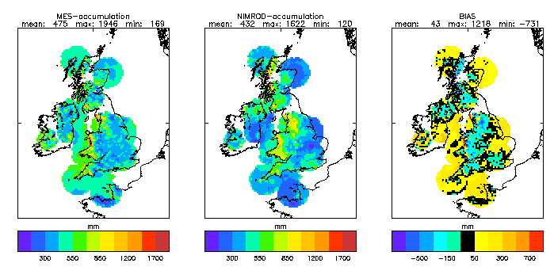
Figure 1: Precipitation accumulation for Autumn 2000. Left: Sum of 6-hourly accumulations from T+12 Mesoscale Model forecast. Middle: Nimrod observations. Right: Bias (difference)
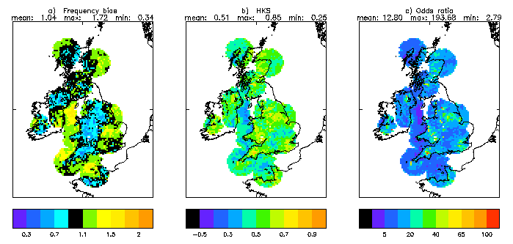
Figure 2: Scores for the rain – no-rain decision (threshold >0.4 mm/6hrs) for 6-hourly accumulations from T+12 Mesoscale Model forecasts at model resolution. a) Frequency bias, b) Hansen-Kuipers score, c) odds ratio.
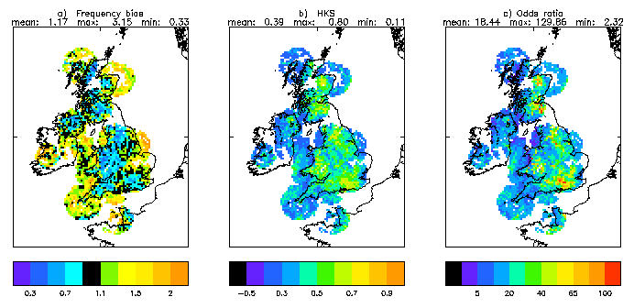
Figure 3 : as fig. 2, but for heavy rain (threshold >4 mm/6hrs).

Categorical data analysis can provide a more focussed view on the occurrence/non-occurrence of events important to customers, such as extreme precipitation. Fig. 2 shows that the model is overall very good in discriminating between rain and no-rain areas (threshold >0.4mm/6hours) even at model resolution, yet during Autumn 2000 it goes one third too often for rain over the relatively warm sea and goes too rarely for rain over the mountains (fig. 2a). Additionally, the low Hansen-Kuipers score (HKS) and odds ratio over the sea quantify the incorrect timing of rainfall there. On the other hand, over most other areas, including the mountains, good rain/no-rain decisions were made by the model. Looking at rather heavy rain events (>4mm/6hours), fig. 3 reveals an amplification of the pattern of differences just described, e.g. there is even more an overestimation of the occurrence of heavy rainfall over the sea; otherwise the area of underestimation spreads further. There is a tendency of having higher scores in areas where many events occurred. This might be an indicator of a high predictability (and, indeed, of a good model!) of the extreme precipitation events in the Autumn 2000, i.e. on average, the events did not occur out of the blue, but the well observed large scale flow was indicative of lots of rain.
Fig. 4 presents a summary of the sensitivity of the model performance over the whole of the domain to forecast range, intensity threshold and resolution for 6 houlry accumulations. The model overestimated the occurrence of all kinds of precipitation events, with the heavy rain overestimated the most. This has been opposite to last summer’s performance, when heavy rain was largely underestimated. The oversensibility of the models convection scheme to the warm sea in Autumn has probably caused this result. Additionally, it could be seen on numerous occasions that the convective cells originating over the sea died out to quickly when moving inland.
The HKS shows an almost exponential decay with forecast range. Good (HKS>0.5) forecasts for the rain/no-rain decision can be made about a day ahead, whereas for heavy rain this holds only for about 12 hours. Increasing the resolution on which model and observations are compared to 36 km translates into a gain of forecast accuracy of roughly 3 hours (see also fig. 6). Roughly the same increase in accuracy is obtained by going from 3 hourly accumulations to 6 hourly accumulations (compare fig. 7 and fig. 6), but the bias increases as well. Note, that the 95% confidence intervals are quite narrow and thus most of the differences between scores when one dependency is varied are significant. For instance, the results for 6 hourly accumulations at 12km resolution are based on a seemingly large sample of about 10⁶ grid squares, thus determining the narrowness of the confidence intervals. But because of the spatial and temporal correlations the effective sample size is smaller and thus the size of the confidence intervals are underestimated at the moment. This will be further investigated in the future.

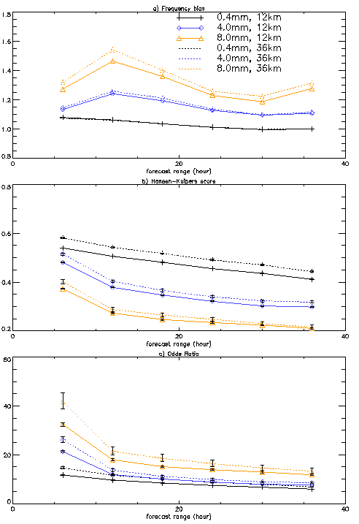
Figure 4: Dependency of scores of 6 hourly precipitation accumulations on forecast range, threshold and resolution of verification. a) Frequency bias, b) Hansen-Kuipers score, c) Odds ratio. 95 % confidence intervals are added to HKS and odds ratio.

Verification of regionally integrated statistics
Compared with temperature, the formation of precipitation has much more the spatio-temporal characteristics of a stochastic process. Thus, it is useful to compare the statistical characteristics of observed and modelled precipitation fields within an area, instead at points (or model squares). Furthermore, for some users, e.g. from the hydrological community, catchment integrated statistics might suffice to first order (France, 1990).
Before discussing some statistics assembled over the whole of Autumn 2000, it might be instructive to look at one short period in detail in order to explain the basis of the collected statistics. It is the period from the 9th to the 12th of October 2000, where a succession of 3 heavy rain events lead to severe flooding in Kent and Sussex (for details see Saunders et al., 2001). Fig. 5a from the peak of the main event, shows the observed precipitation analysed by Nimrod from 02-03GMT on the 12th of October. For the same period, figs.5 b-f present successive forecasts by the mesoscale model. The area outlined in black comprises Kent and East and West Sussex. All the following statistics and the numbers at the top of the plots are collected over these 51 model squares, i.e. an area of about 7300 km² . While this is an area certainly bigger than most catchments, it is a size of an area where we expect the model to show some skill. This one hourly snapshot shows that earlier model runs were best in terms of positioning error and intensity error, whereas the short term forecast (fig.5 a, started during the event) supressed precipitation.
Hourly time series of the statistical measures just described of observations and all forecasts with an ‘age’ between 18 and 24 hours are plotted in fig. 6 for the 9th to 12th of October 2000, comprising 3 major rain events. Whereas the accumulation in the earlier events was overestimated, a negative bias occurs for the main event, especially at the beginning of the event. This is partly due to a error in positioning the rain to far southwest (cf. 5e). The spatial probability for rain in the area is well simulated, again peaking to late in the main event (fig. 6c). The maximum values have been surprisingly well forecast (fig. 6d). Using rain gauges and radar data at 5km resolution, a frequent suspicion had been in the past that the model is not able to produce the maximum rain amounts observed in nature. However, using model and observational data at the same resolution does not show a strong indication of a negative model bias in heavy rain. Thus, the necessity of using data of comparable resolution in verification is stressed.

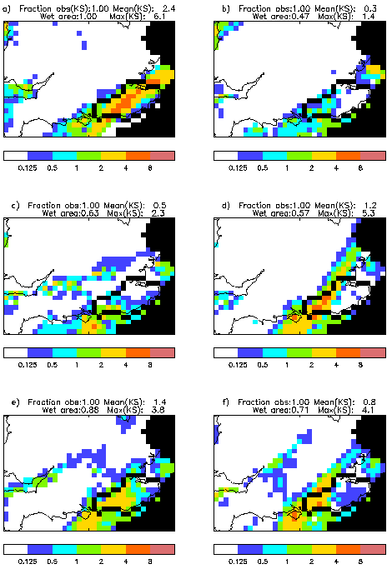
Figure 5: Observed and forecast precipitation accumulations for 02 GMT to 03 GMT on 12th October, 2000. a) Nimrod observation. Forecasts: b) 2-3hr, c) 8-9hr, d) 14-15hr, e) 20-21hr, f) 26-27hr . Statistics taken over Kent/Sussex (area outlined in black; ‘randomly scattered’ black squares show missing observations). Statistics comprises fraction of area of Kent/Sussex covered by observations; mean over area; ‘wet’ fraction of area where accumulation was >0.1mm/hr; average of wettest 10% squares as an indicator of maximum rainfall.
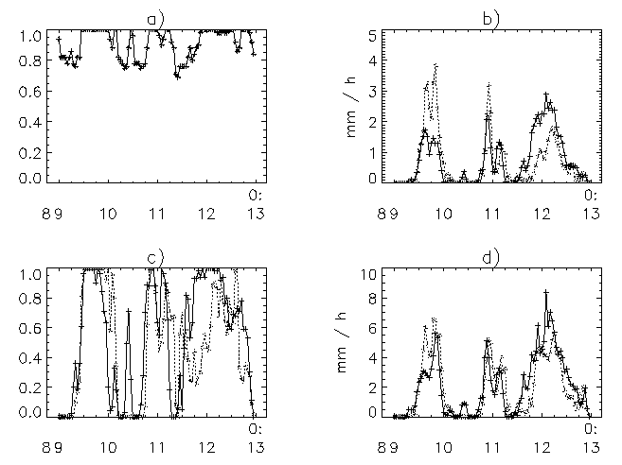
Figure 6: Time series, 9-12 October 2000, showing statistics of hourly accumulations over Kent/Sussex. Solid line: Nimrod observation; dotted line: accumulations derived from 18 hour to 24 hour forecasts. a) Fractional area covered with observations; b) mean accumulation; c) ‘wet’ area where accumulation was > 0.1 mm/hr; d) mean of wettest 10% of squares.
After having looked at a specific example of how areal integrated statistics can be done, we now present statistics assembled over the whole of autumn 2000. Fig. 7 compares the average probability of having rain in one hour in an area. Thus, there was about a 20% chance for getting wet in Southeast England in any hour, whereas it was roughly twice as likely in Western Scotland. Roughly speaking, the model had a tendency to go to often for rain in the less wet areas and it went to seldom for rain in the very wet areas. These biases increase with forecast range.
The Briers score can be seen as a measure for the mean squared difference between forecast and observed probabilities (Wilks, 1995):
From this the Brier skill score can be defined, which measures the additional skill a forecast provides over a reference forecast (here the sample mean):
Fig. 8 shows maps of the Brier skill score for two forecast ranges.
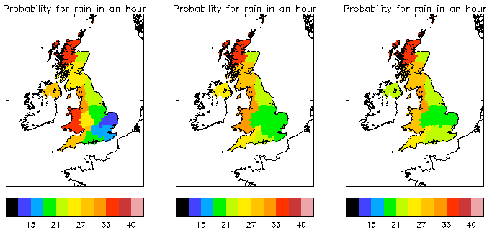
Figure 7: (Spatial) probability for rain in one hour in an area in autumn 2000. Left: Observation (Nimrod), middle: 6-12 hrs forecasts, 18-24 hrs forecasts.
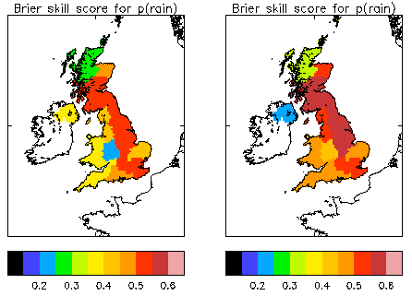
Figure 8: Brier skill score for the probability of rain in one hour in an area in autumn 2000. Left: 6-12 hrs forecasts, right: 18-24 hrs forecasts.

5. Summary
Nimrod (radar) data are relatively good for verifying mesoscale quantitative precipitation forecasts, because of their spatial and temporal resolution and near real time availability. One ought to compare model forecasts with observations having at least the resolution of the model. Time series of regionally integrated statistics and categorical data analysis provide scientifically based, yet customer friendly, measures to verify quantitative precipitation forecasts. The extreme precipitation in England and Wales in autumn 2000 was relatively well forecasted by the Met. Office Mesoscale Model.

References
Agresti, A., (1996) An Introduction to Categorical Data Analysis. John Wiley & Sons, Inc., 290 pp.
France, P., (1990) Utilizing radar estimates of areal rainfall coverage as a verification and forecasting tool. National Weather Digest, 15, 17-22.
Golding, B.W. (1998) Nimrod: a system for generating automated very short range forecasts. Meteorol. Appl., 5, pp.1-16.
Hamill, T.M., (1999) Hypothesis tests for evaluating numerical precipitation forecasts. Wea. Forecasting, 14, 155-167.
Hansen, A.W. and W.J.A. Kuippers, (1965) On the relationship between the freuency of rain and various meteorological parameters. Meded. Verh., 81, 2-15.
Harrison, D.L., Driscoll, S.J. and M. Kitchen, (2000) Improving precipitation estimates from weather radar using quality control and correction techniques. Meteorol. Appl., 6, pp.135-144.
Kitchen, M. and R.M. Blackall, (1992) Representation errors in comparisons between radar and gauge measurements of rainfall. J. Hydrol., 134, pp. 13-33.
Pamment, J.A., and B.J. Conway, (1998) Objective identification of echoes due to anomalous propagation in weather radar data. J. Atmos. Ocean Tech., 15, 98-113.
Richardson, D.S. (2000) Skill and relative economic value of the ECMWF ensemble prediction system. Q.J.R. Meteorol. Soc., 126, 649-667.
Saunders, F., Chalcraft, B. and M. Goeber (2001) The Sussex and Kent floods of 11 and 12 October 2000, as observed and as forecast by Met Office NWP models. Accepted for publication in Weather.
Stephenson, D.B., (2000) Use of the 'odds ratio' for diagnosing forecast skill. Wea. Forecasting, 15, 221-232.
Wilks, D. S., (1995) Statistical methods in the atmospheric sciences. Academic Press, p. 464.
Woodcock, F., (1976) The evaluation of yes/no forecasts for scientific and administrative purposes. Mon. Wea. Rev., 104, 1209-1214.

Acknowledgements: We thank Glen Harris and Dawn Harrison for providing data and information about them and Clive Wilson for discussions about methods and results.

