Verification of Precipitation Areas

Elizabeth E. Ebert
Bureau of Meteorology Research Centre, Melbourne, Australia
e.ebert@bom.gov.au

Introduction

One of the most effective ways to present a rainfall forecast is as a chart. In fact, many of the methods used to forecast rain, such as numerical weather prediction models and radar-based nowcasts, naturally produce spatial rain fields. Most of the verification techniques and statistics used to evaluate rainfall forecasts at individual locations can be applied to the verification of precipitation areas, but there are additional techniques that are particularly well suited for spatial verification. This paper describes the practical application of several methods for verifying precipitation areas, starting with visual inspection, continuing to verification statistics computed from forecasts and observations matched in time and space, and finishing with entity-based methods that consider whole rain systems.

Visual verification

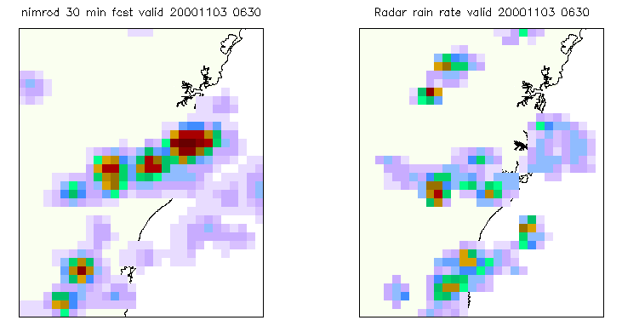
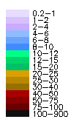
Visual, or "eyeball", verification, is simply the comparison of a map of forecast rainfall against a map of observed rainfall. As the old adage goes, "a picture is worth a thousand words," and an enormous amount of useful information can be gained by careful examination of the forecast rain field when placed side by side with the corresponding field of observed rain. In preparing these rain maps it is important to make effective use of color to highlight the regions of greatest interest. For example, heavy rain can be represented by a bright color or a dark shade. An example of a well presented visual forecast verification is presented in Figure 1 for a nowcast of rain associated with severe convection during the WWRP Sydney 2000 Forecast Demonstration Project.
Figure 1. 30-minute forecast from the Nimrod algorithm, and validating radar observations from 0630 UTC, 3 November 2000 in Sydney, Australia.

QPF verification using match-ups in space and time

Spatial QPFs derived from numerical weather prediction (NWP) model output, radar-based nowcasts, digitized hand-drawn rain forecast charts, etc, generally take the form of grids. The standard QPF verification statistics can be applied to spatial estimates by treating them as a matched set of forecasts/observations at individual points.

There are two strategies for obtaining this matched set. The first is to analyze the observations to the same grid as the forecast, while the second is to interpolate the forecasts to the locations of the observations. Both strategies are valid, and the most appropriate approach depends on the goal of the verification.

If the goal is to measure the accuracy of the forecast for a set of specific locations, then one should interpolate the forecast to those locations and use the actual observations as verification data. This is the verification procedure used operationally at ECMWF and the Deutscher Wetterdienst. If the goal is to assess the forecast model or method (for example, to compare different versions of a NWP model), then it may be more appropriate to analyze the observations onto the same grid as the forecast and use this analysis as verification data. This verification approach is used operationally at NCEP and the Australian Bureau of Meteorology. Some advantages of the second approach are that the gridded analysis better represents the grid-scale quantities predicted by the model, and the sampling is spatially uniform (i.e., not biased toward regions with greater observation density). A potential disadvantage is that the analysis tends to smooth the observations.

There are many methods to objectively analyze rain gauge observations to a regular grid, including simple averaging, inverse distance weighting, statistical interpolation, kriging, and spline fitting. Descriptions of these methods may be found in Bussieres and Hogg (1989), Hutchinson (1995), Seo (1998), Weymouth et al. (1999), and Krajewski et al. (2000). Differences between rainfall analyses using these methods occur almost entirely at the smallest scales. Other issues affecting the quality of the gridded analyses include quality control of the input data and spatial density of observations.

The verification statistics commonly used in spatial QPF verification are summarized in Table 1. Formulae for these statistics may be found in Stanski et al. (1989) and Wilks (1995). The first group lists continuous statistics that quantify errors in forecast rain amount. The second group gives categorical statistics that are computed from the 2x2 (rain/no rain) contingency table, and these quantify errors in forecast rain occurrence.

Verification of gridded QPFs from NWP models is now done routinely at many national operational centers. A good model rainfall forecast depends on the accurate prediction of many other quantities including atmospheric moisture and vertical velocity, and for this reason a good rainfall prediction often implies a good forecast overall. Practically speaking, rainfall is one quantity for which verification data are available on a regular basis. An example of an operational daily QPF verification is shown in Figure 2 for the Australian regional NWP model.
Table 1. Commonly used scores for spatial QPF verification.

Score What it measures

Mean difference Forecast bias

Mean absolute error Average error magnitude
RMS error Error magnitude, greater emphasis to outliers
Correlation coefficient Correspondence of forecast to observed rain pattern
Accuracy Correspondence of rain and no-rain areas
Bias score Tendency to under- or over-forecast rain area
Probability of detection Ability to predict observed rain
False alarm ratio Tendency to predict rain when/ where none occurred
Threat score Penalizes both misses and false alarms
Equitable threat score As above, accounts for wet or dry regime
Hanssen & Kuipers ("true skill") score Accuracy for events + accuracy for non-events – 1
Heidke skill score Related to TSS, can use multiple rain categories

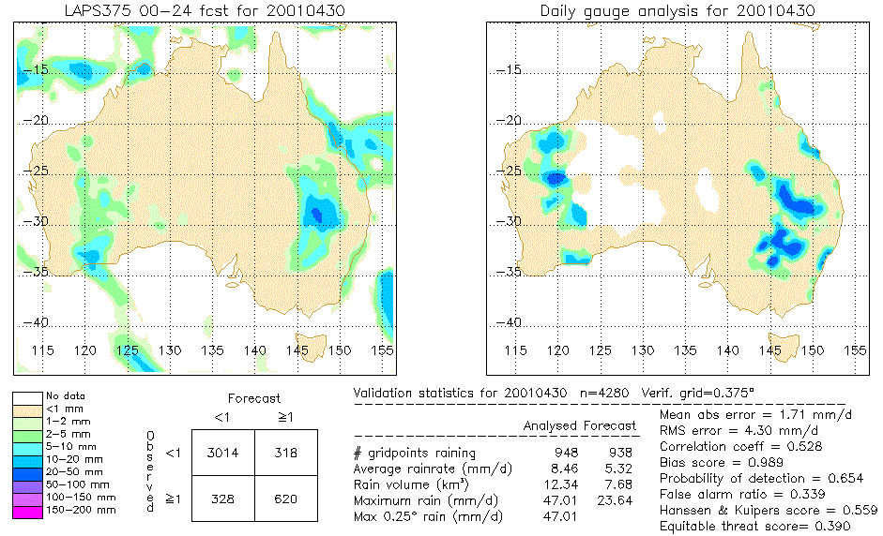
3. Space-time QPF verification
Figure 2. Gridded QPF verification of the Australian LAPS regional NWP model on 30 April 2001.

If spatial QPFs are available for some period of time over a given domain, then the addition of the time dimension enables the verification statistics to be computed in a number of different ways. The most common approach, used in most operational centers, is to pool all forecasts/observations in time and space to generate summary statistics. These summary statistics are generally presented as tables, bar charts, or as a function of rain threshold or forecast range as described below.
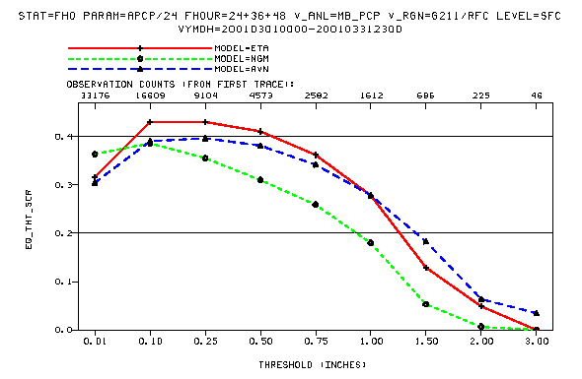
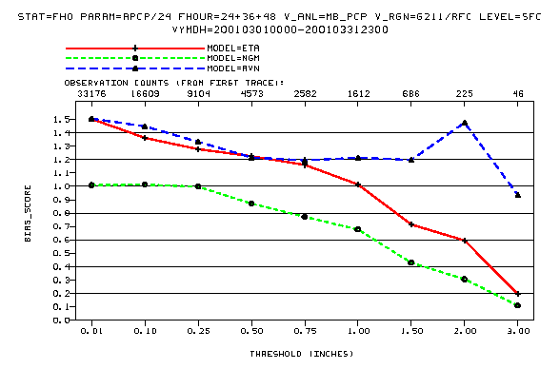
Figure 3. Bias score (top) and equitable threat score (bottom) as a function of rain threshold for three NWP models verified over the United States during March 2001.
Usually the 2x2 contingency table and statistics derived from it use a rain threshold that is appropriate for distinguishing "rain" from "no (significant) rain" (for example, 1 mm d⁻¹ for 24 h rainfall). To measure the forecast ability for heavier rainfall one can recompute the categorical statistics for progressively greater rain thresholds, and plot the results as shown in Figure 3. This type of plot has been produced for many years at major national operational centers, and is often used to intercompare the skill of different forecast models or forecast periods.

In assessing the value of a forecast, it is useful to compare its skill against that of an unskilled reference forecast such as persistence, climatology, or random chance. One way to do this is to compute the verification statistics for the reference forecast and compare them against the results for the skilled forecast, as is demonstrated in Figure 4. Another is to compute a skill score with respect to the reference forecast. If S is a particular verification statistic, then the skill score associated with S would be given by

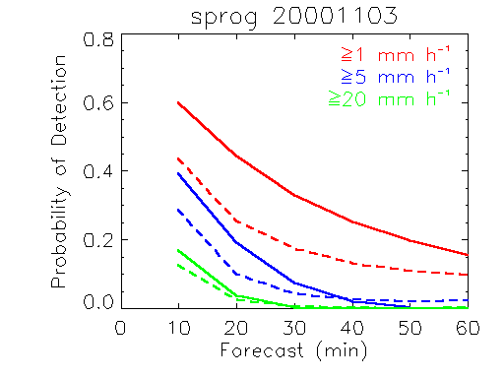
Figure 4. Probability of detection as a function of forecast range and rain threshold for SProg nowcasts and persistence on 3 November 2000 in Sydney, Australia.
______ nowcast
_ _ _ _ persistence

The true skill score and Heidke skill score are examples of skill scores that compare the accuracy of the given forecast against the accuracy of a forecast of random chance. For short range forecasts persistence should be considered the most appropriate reference for assessing forecast value.

While summary statistics are undoubtedly very useful for characterizing the overall performance of a forecast model or method, they may give misleading results if there are distinctly different regimes or modes of variability in the space-time domain. To give an example, Figure 5 shows the equitable threat score for the ECMWF model for tropical Australia north of 20°S. The solid line gives the results for all gridpoints pooled in space in time, and shows ETS values of ~0.4 for a threshold of 1 mm d⁻¹. However, the seasonal results are significantly worse than the annual results, and the dependence on rain rate is quite different, especially during tropical winter. Tropical Australia has a monsoon climate characterized by frequent heavy rain in summer and very little rain in winter. Fig. 5 suggests that the model shows good ability to predict the monsoon variability but much less skill in predicting the day-to-day variability of the rainfall.
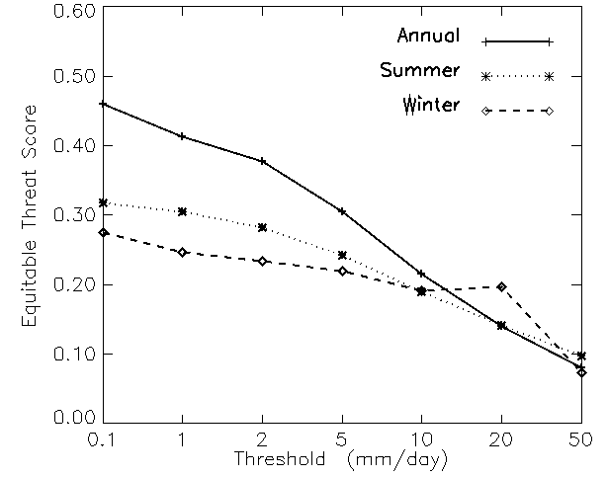
Figure 5. Equitable threat scores for NWP QPFs from the ECMWF model over tropical northern Australia during 1997-1999 for all months, summer months (DJF), and winter months (JJA).
If the set of forecasts/observations are pooled in time but not space, then one can compute spatially varying temporal verification statistics. When plotted on a map, they show the spatial dependence of QPF ability. An example of this approach is shown in Figure 6.

On the other hand, if the set of forecasts /observations are pooled in time but not space, then temporally varying spatial verification statistics are obtained. These can be plotted as time series, as in Figure 7. This approach enables events with particularly good or bad forecasts to be easily found and associated with cases of heavy or widespread rain, for example.
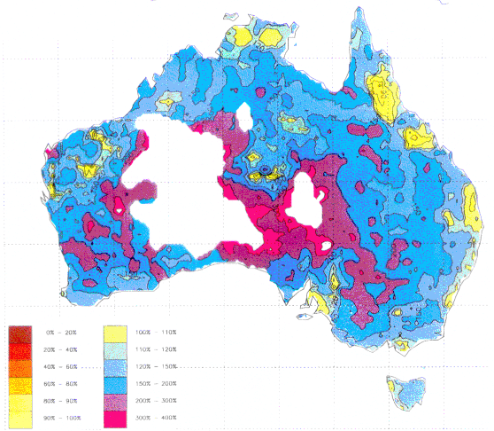
0.0-0.2
0.2-0.4
0.4-0.6
0.6-0.8
0.8-0.9
0.9-1.0
1.0-1.1
1.1-1.2
1.2-1.5
1.5-2.0
2.0-3.0
3.0-4.0
No data
Figure 6. Bias score for the Australian regional NWP model during June 1995-November 1996.
QPF verification using (grid)point match-ups is quite simple in concept and gives competely objective results. However, there are some limitations of this approach.

We have already seen how some summary results can be misleading when the pooled data set includes more than one mode of variability. A spatial example of this problem is the case of compensating errors producing reasonable mean rain rate forecasts and bias scores when, for example, too much rain in one part of the domain is offset by too little rain in another part of the domain.

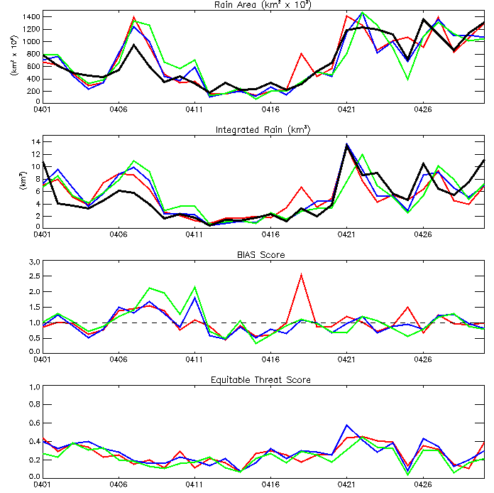
This verification approach also tends to reward conservative forecasts. Consider the case of two nearly identical forecasts of an observed heavy rain event, one with the an appropriately heavy rain rate in the center, the other with a much smaller maximum rain rate, but both forecasting the location of the system some distance away from its observed location. According to most forecasters the one with the heavy rain would be considered the better of the two QPFs, yet traditional verification statistics severely penalize such a forecast. Because correctly predicting the location of heavy rain is difficult, QPFs that "hedge" by not predicting the heaviest rain rates tend to do better in the objective verification stakes, even though those forecasts may be less useful in a practical sense.
OBS LAPS 24 h LAPS 36 h LAPS 48 h

Figure 7. Verification statistics for the Australian regional NWP model (LAPS) over Australia during April 2001.

4. Entity-based QPF verification

An alternative, perhaps more intuitive, approach is the evaluation of forecast rain entities, or contiguous rain areas (CRAs) ("blobs" on a rainfall map). Proposed by Ebert and McBride (2000), the bulk properties of the forecast rain entity are verified against the bulk properties of the observed rain entity. The verification quantities of interest include the position error of the forecast, the difference between the forecast and observed rain area, volume, and mean and maximum rain rates, and the correlation between the position-corrected forecast and observations. In essence, entity-based QPF verification quantifies "eyeball" verification results such as "too far to the east", "not strong enough", "rain area too widespread", etc.

The entity-based approach addresses some of the limitations of simple (grid)point verification. By isolating individual rain systems it avoids some of the ambiguity that occurs when more than one rain system is present in the domain. It attempts to separate out the effects of location error from other sources of error. Finally, because the emphasis is on the properties of the rain entities, this method does not favor conservative forecasts.

Formally, the CRA is simply the union of the forecast and observed entities for a given rain system. This is illustrated in Figure 8. The entities are defined by a threshold isohyet, which may be specified to have very low value to capture all rainfall, or a high value if heavy rainfall is the focus. For example, Ebert and McBride (2000) found 5 mm d⁻¹ to be a useful threshold for CRA verification of 24-hour QPFs from NWP models.

The position error is determined (to the nearest gridpoint) by pattern matching. This is done by horizontally translating the forecast over the observations until a best fit criterion is satisfied, then measuring the vector displacement of the shifted forecast. Possible best fit criteria include minimization of the total squared error (used by Ebert and McBride, 2000), maximization of the spatial correlation coefficient, and maximum overlap. The verification domain for the CRA is the set of gridpoints in the CRA before and after the forecast shift, thus isolating the event of interest from other unrelated rain events elsewhere in the domain. The rain area, volume, and mean and maximum rain rates are computed from the forecast and analyzed points within the verification domain.

An example of a CRA verification is shown in Figure 9 for the Australian regional NWP model, LAPS, for a flood situation in eastern Australia. In this example a threshold of 20 mm d⁻¹ was used to isolate the area of interest. The forecast location of the system was just over 1° latitude/ longitude to the northwest of the observed location. Shifting the forecast to the correct location reduces the RMS error by nearly 50% and markedly improves the correlation coefficient with the observations.
Observed
Forecast
Figure 8. Schematic diagram of a CRA, with the arrow showing the optimum shift of the forecast.

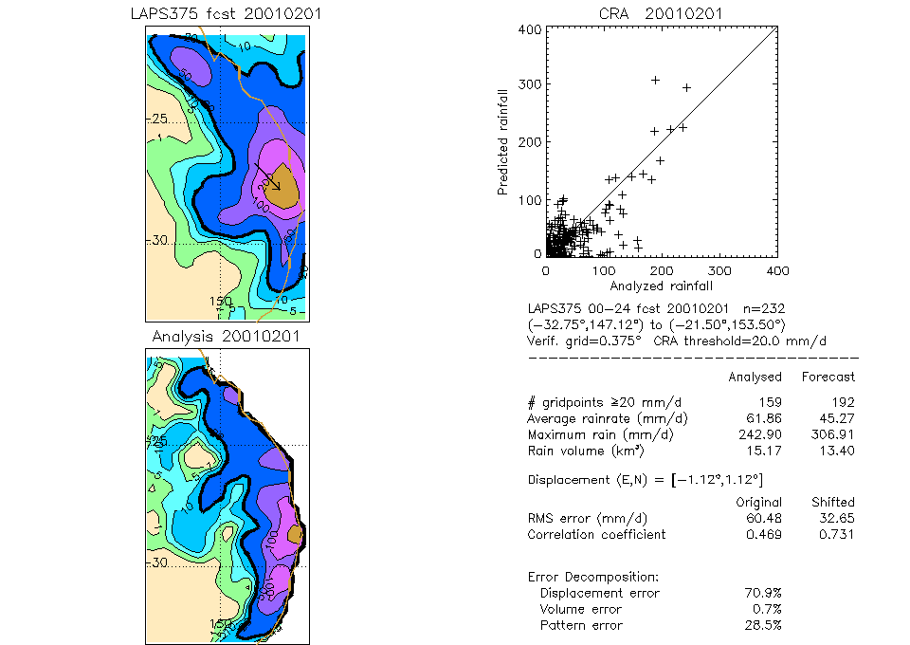
When the period of rain accumulation is large compared to the time scale of individual storm elements, then the effects of cell growth and decay integrate to produce a relatively smooth field. In this case the various methods of pattern matching (squared error minimization, correlation maximization, and binary overlap) usually give similar results. However, if cell growth is evident in the rain pattern, as is often the case for nowcasting, then the choice of pattern matching method does impact on the results. This ambiguity in pattern matching is one of the disadvantages of entity-based verification. In fact, if the forecast does not resemble the observations sufficiently, it may not be possible to make an objective association between the two.
Figure 9. CRA verification for a rain event predicted by the Australian regional NWP model on 1 February 2001.

Figure 10 shows two displacement estimates for a 30-minute nowcast from the SProg algorithm, and validating radar observations from 0635 UTC on 3 November 2000 in Sydney (same storm as shown at the bottom of Fig. 1 -- note how the radar "truth" depends on the analysis embedded in the algorithm!). Pattern matching using squared error minimization (dashed arrow) suggests that the forecast should be shifted 9 km to the southwest to match the heavy rain centers. A second pattern matching method, maximum binary overlap followed by squared error minimization in the immediate vicinity of the result of the first step (solid arrow), suggests that the forecast should be shifted 7 km to the northeast, quite different from first result. The second displacement estimate is probably the correct one, as it better represents the movement of the larger rain system, even though the forecast did not predict the development of the convection southwestern side of the system.

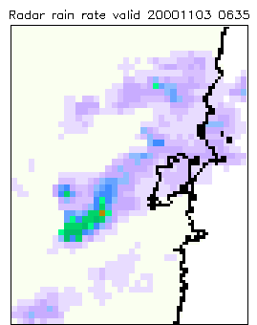
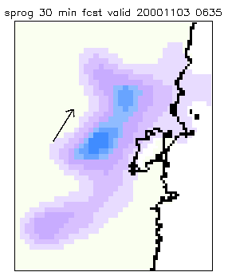
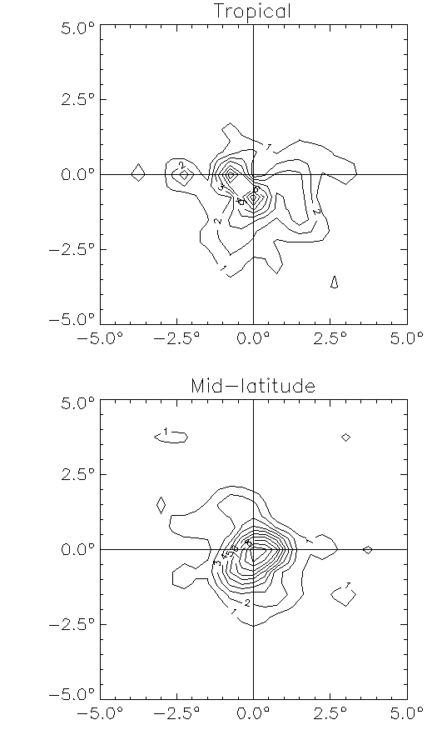
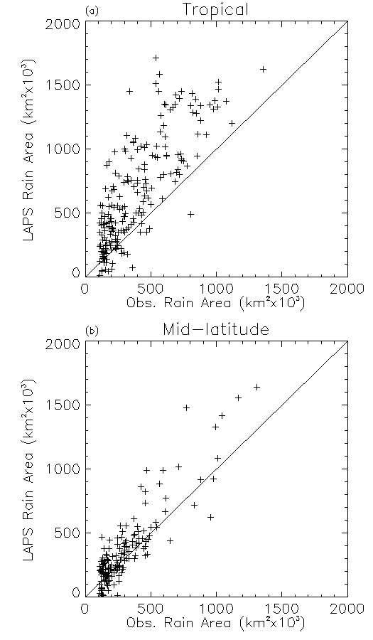
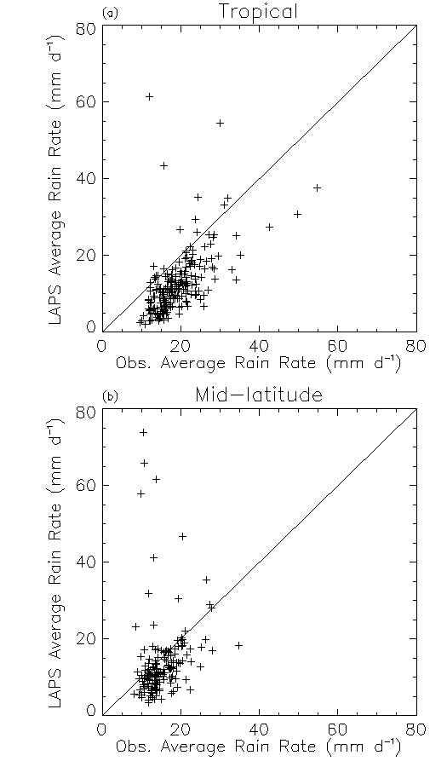
CRA verification lends itself well to characterizing systematic errors when a large number of rain systems are verified. Figure 11 shows scatter plots of forecast versus observed rain area and conditional rain rate, as well as a contour plot of the frequency of location errors. In the tropics the model generally overestimated the rain area and underestimated the intensity of rain systems, and their predicted location was frequently too far to the south. The systematic errors in the mid-latitudes were less pronounced.
Figure 10. 30 minute nowcast from the SProg algorithm on 3 November 2000 (left), and corresponding verifying radar rainfall analysis (right). The dashed arrow shows the forecast shift estimated using squared error minimization, while the solid arrow shows the forecast shift estimated using binary matching followed by local squared error minimization.
Figure 11. Forecast versus observed rain area (left) and mean rain rate (center), and frequency of location errors (right, in percent) for rain systems predicted by the Australian regional NWP model during September 1997 to August 2000.

When the displacement is determined using squared error minimization then it is possible to write the mean squared error as the sum of three contributions:

MSE_{total} = MSE_{displacement} + MSE_{volume} + MSE_{pattern}

(see Ebert and McBride, 2000, for details). The difference between the mean square error before and after translation is the contribution to total error due to displacement,

MSE_{displacement} = MSE_{total} - MSE_{shifted}

The error component due to volume represents the bias in mean intensity,

where F and X are the CRA mean forecast and observed values after the shift. The pattern error accounts for differences in the fine structure of the forecast and observed fields,

MSE_{pattern} = MSE_{shifted} - MSE_{volume}

For example, for the forecast shown in Fig. 9 about 70% of the error could be accounted for by error in the forecast rain position, with most of the remaining error being associated with error in the fine scale structure.

Another benefit of viewing a spatial QPF as an entity, rather then a collection of (semi-) independent gridpoints, is that the forecast entity itself can be classified as a hit, miss, false alarm, etc. If particular criteria for a "good" forecast are specified, an objective assessment of the forecast can easily be made.

It could be argued from a forecaster's point of view that the two most important aspects of a useful QPF are that the location of the predicted rain must be close to the observed location, and the predicted maximum rain rate must be within a reasonable range of the observed maximum rain rate. Ebert and McBride (2000) suggested a classification of forecast rain events based on these two criteria, as shown in Table 2. They proposed the following criteria for 24 h NWP QPFs: the forecast rain system must be within 2° lat/lon or one effective radius of the rain system (but not farther than 5°) from the observed location, and the maximum rain rate must be within one category of observed. They used rain categories of 1-2, 2-5, 5-10, 10-25, 25-50, 50-100, 100-150, 150-200, >200 mm d⁻¹. The criteria for different space and/or time scales would undoubtedly be different.

Table 2. Classification of forecast rain events (after Ebert and McBride, 2000)

 |  | Forecast Maximum Rain Rate
 |  | Too Little | Approx. Correct | Too Much
Displacement  of forecast  rain pattern | Close | Under-estimate | Hit | Over-estimate
Displacement  of forecast  rain pattern | Far | Missed Event | Missed Location | False Alarm

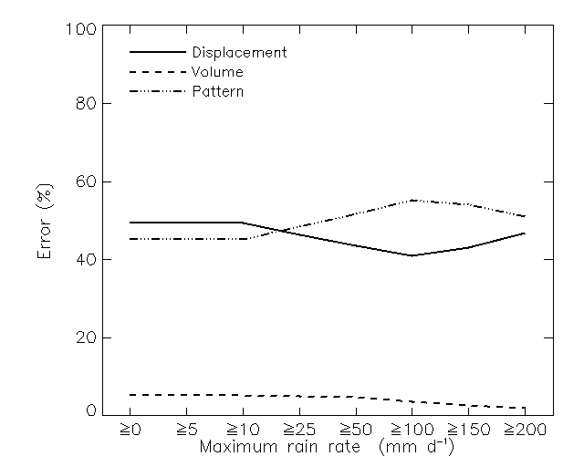
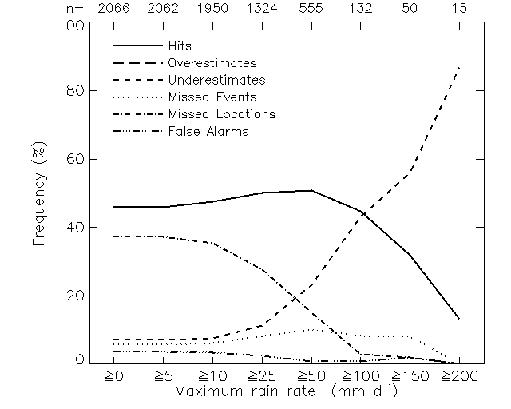
By plotting the frequencies of the event classes as a function of the observed maximum rain rate (Figure 12), one can see how the success of the QPFs depends on the intensity of the rain events. Using the 24 h criteria given earlier to evaluate the Australian LAPS model QPFs, hits and missed locations were the most forecast classes for all events (maximum ≥0 mm d⁻¹), suggesting that the storm intensity was well forecast but the storm location often was not. As the maximum rain rate increased to ≥50 mm d⁻¹ the frequency of hits peaked, then decreased with increasing intensity of the event. The frequency of underestimates increased with increasing rain rate, indicating that the stronger the storm the more likely the model was to underestimate its intensity. On the positive side, the location of the most intense rain events was well predicted, with only 12% of events with maxima ≥100 mm d⁻¹ falling into the categories of missed events, missed locations, and false alarms.
Figure 12. Frequency of rain event forecast classification (left) and contribution from error sources (right) as a function of observed maximum rain rate within the entity, for 24 h QPFs from the Australian regional NWP model during July 1995-June 1999. The numbers along the top of the left diagram give the number of events in each rain rate category.

Displacement errors accounted for half of the total error for all events, with pattern errors responsible for most of the remaining error (45%). As the observed intensity increased the structure of the analyzed rain field usually became more variable, and the pattern errors dominated. The relative contribution from volume error was small for events of all magnitudes.

5. Summary

The definition of QPF “success” depends on the requirements of the user. The success of spatial QPFs can be qualitatively and quantitatively measured in many ways, each of which tells only part of the story. As illustrated schematically in Figure 13, the three approaches described in this paper compliment each other in describing QPF skill. The particular requirements of the user will often mean that one spatial QPF verification approach is more appropriate than the others for making the necessarily evaluation.

Maps of forecast and observed rainfall enable a subjective visual assessment to be made. Statistics based on (grid)point match-ups are completely objective and generally provide good summary assessments, particularly when the number of forecasts is large. However, care must be taken in interpreting results when the forecasts include distinctly different regimes or modes of variability in the space-time domain Entity-based verification focuses on the properties of the rain systems, combining some of the features of visual and gridpoint-based verification. This approach could be used to verify many other types of forecasts including low pressure centers, tropical cyclones, and fire weather areas, to name a few. However, potential ambiguity in the pattern matching makes this technique only semi-objective.
Figure 13. Schematic diagram showing attributes of various approaches to spatial QPF verification.
Objective
Subjective
Point
Area
(grid)point match-ups
Precision
Meaning
maps
entities

References

Bussieres, N. and W. Hogg, 1989: The objective analysis of daily rainfall by distance weighting schemes on a mesoscale grid. Atmosphere-Ocean, 3, 521-541.

Ebert, E.E. and J.L McBride, 2000: Verification of precipitation in weather systems: Determination of systematic errors. J. Hydrology, 239, 179-202.

Hutchinson, M.F., 1995: Interpolating mean rainfall using thin plate smoothing splines. Int. J. Geog. Inf. Sys., 9, 385-403.

Krajewski, W.F., G.J. Ciach, J.R. McCollum, C. Bacotiu, 2000: Initial validation of the Global Preciptiation Climatology Project monthly rainfall over the United States. J. Appl. Meteor., 39, 1071-1086.

Seo, D.-J., 1998: Real-time estimation of rainfall fields using rain gauge data under fractional coverage conditions, J. Hydrol., 208, 25-36.

Stanski, H.R., L.J. Wilson and W.R. Burrows, 1989: Survey of common verification methods in meteorology. World Weather Watch Tech. Rept. No.8, WMO/TD No.358, WMO, Geneva, 114 pp.

Weymouth, G., G.A. Mills, D. Jones, E.E. Ebert, M.J. Manton, 1999: A continental-scale daily rainfall analysis system. Austr. Met. Mag., 48, 169-179.

Wilks, D.S., 1995: Statistical Methods in the Atmospheric Sciences. An Introduction. Academic Press, San Diego, 467 pp.

