Hailstorm at 19 August 2000 over Berlin
and Issues of Verification of Deep Convection

Matthias Jaeneke
Deutscher Wetterdienst, Bildungs- und Tagungszentrum
D-63225 Langen, Paul-Ehrlich-Str. 39
Fax 0049-6103-707-403, Email Matthias.Jaeneke@dwd.de

1. The Role of Case-studies in Verification

Verification methods usually focus on quantitative statistical evaluation of large data sets. This results in statistical scores measuring the mean absolute quality of forecasts or mean relative skill compared to standard forecasts. In this context no single verification score is able to describe verification completely, verification is a multi-dimensional problem. A single verification value only stands for one aspect of the matching of forecast and observational truth. Even relatively simple forecast parameters like temperature or wind comprise several aspects of verification. Much more complexity is apparent when assessing forecast errors related to cloudiness, precipitation or weather.

- To understand results of quantitative verification of these parameters it appears necessary, to get insight into their synoptical and mesoscale framework, to extract their diagnostical implications.
- Additionally : Statistical Verification always sums up from a series of different forecast situations with possibly contradictory error tendencies.

Therefore it is sensible, to compliment statistical evaluation of forecasts by qualitative and diagnostic case-studies, representing typical or critical weather situations.

- Case studies provide demonstrations of strengths and weaknesses of forecasts in single weather situations.
- Case studies are appropriate to stratify verification into typical classes of weather cases, for instance high impact weather.

There are moreover operational aspects that illuminate the necessity of case studies in
verification:

- Single case studies are adapted to problems and needs of the operational forecaster and end-user.
- Case studies are able to show the range of day to day variablility of forecast quality.

Case studies are integral part of verification and reflect qualitatively the implications of the assessment of forecasts.

2. The Berlin Hailstorm, Synoptical and Mesoscale Development

Local Hailstorm Data

The Berlin hailstorm of 19 August 2000 was a mesoscale event which had its final local development in early evening directly over the city area of Berlin. Hail-stones of up to 6 cm and heavy rain caused wide-spread break-down of traffic and damages. Maximum wind-gusts reached 40 knots. As the analysed precipitation distribution from rain-gauges shows, the severe storm developed in two parallel streaks from west to east.

Synoptical Situation

The synoptical situation of this day was dominated by a marked frontal zone over western and central Europe ahead of a broad upper trough over the western coasts of Europe. The frontal zone was seperating maritime polar and subtropical air, the Berlin area was still mainly influenced by the subtropical air. Two trailing cold-fronts of a cyclone over Great Britain and the North-Sea were slowly moving southeastwards, the second one reaching Berlin towards the evening. The subtropical air possessed widespread potential instability, supporting early mesoscale thunderstorm development over France and southwestern Germany, clearly visible in the IR Meteosat image in the night before (Fig.1).
B
B

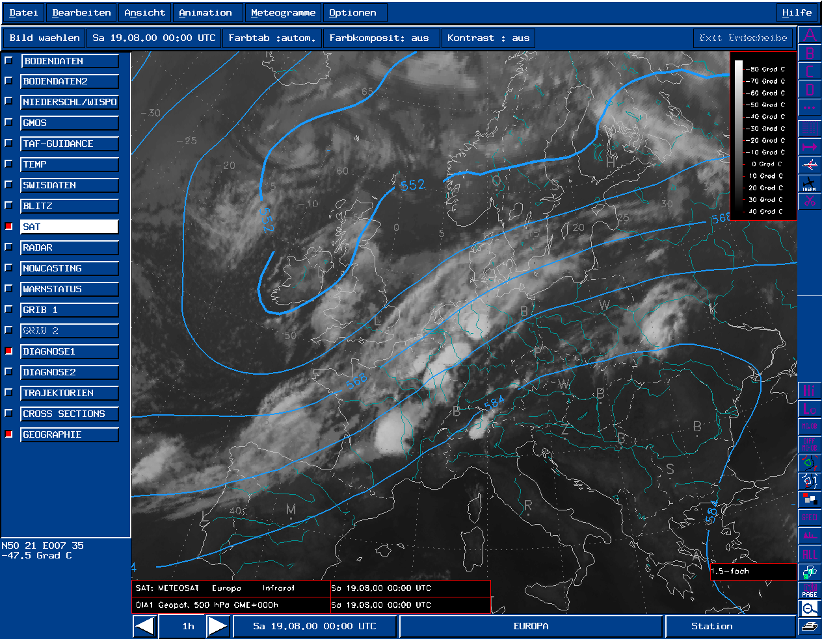
Fig.1 : IR Meteosat image + GME analysis 500 hPa 19-08-00 00 UTC. B denotes Berlin

Mesoscale Development

The series of IR images of the day revealed that the more northern trailing cold-front was especially active. Along this front the temperature contrast increased und some new cells were developing from noon. They moved east-northeastwards reaching top-cloud-temperatures of minus 50°C to minus 55°C. From 15.00 UTC (17 h Central European Summer Time) the leading cell exploded, turned to the east and arrived at Berlin between 16 and 17 UTC (Fig.2).
B
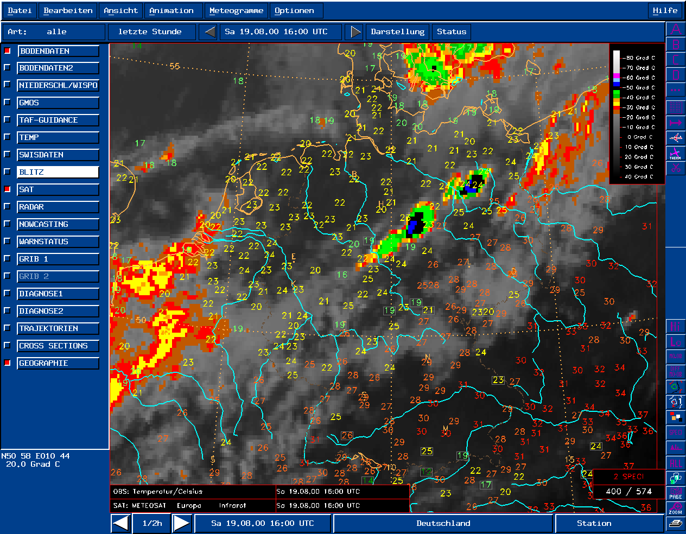
B
Fig.2 : NOAA IR image color-coded + T2m temperatures 19-08-00 16 UTC. B denotes Berlin

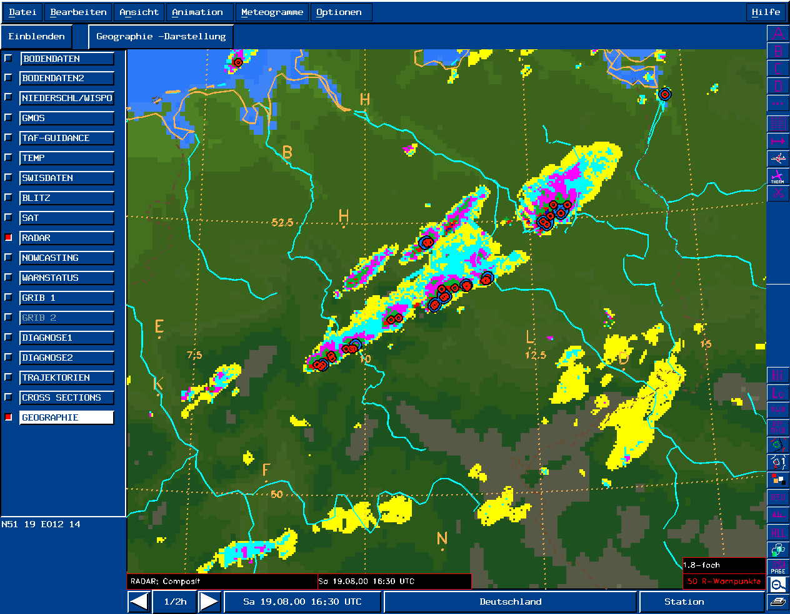
Fig.3 : Radar composite 19-08-00 16.30 UTC. B denotes Berlin
More details could be extracted from radar imagery. Southwest-northeast oriented strong multicells moved from western Germany very fast to the central region, apparently heading into a region north of Berlin. From 15 UTC with easterly movement the first of lined up radar cells expanded to a broad cluster with mesoscale dimensions of more than 50 km. Reflectivity surpassed in the inner parts of the cluster values of 55 dBZ. Special advice to heavy development gave red and blue warning markers. The red markers denote imminent danger or existence of strong showers (markers given in case of at least 40 dBZ in heights of 6 km, 10 dBZ in heights of 8 km). The blue markers stand for danger of hail (these markers given in addition to the red markers in case of at least 46 dBZ above freezing level). The number of markers was largest when the storm system reached Berlin at about 16.30 UTC (Fig.3). 1 1/2 hours later another cell cluster crossed Berlin from the west.

3. Verification of DWD-LM concerning the Forecast Thunderstorm Activity

Model Products of DWD for Thunderstorm Situations

Two DWD NWP models are used in the operational forecast services :

- GME (global model with a horizontal resolution of 60 km and 31 layers)
- LM (regional model with horizontal resolution of 7 km and 35 layers)

Besides basic products special model-output is designed for thunderstorm forecasting:

- GME fields : KO-Index (Konvection-Index, representing the vertical gradient of equivalent potential temperature)
- LM fields : 3-h precipitation amounts, model weather, convection type
- Local products : Direct model weather and statistical postprocessing based on MOS and PPM, using GME and LM.

The model weather is a synoptically controlled interpretation of model output, producing weather phenomena within the framework of WMO weather codes.

- Model thunderstorm is given if KO-index < 1, convectional depth > 400 hPa, convective cloud top temperatures < -25°C and convective precipitation amount
> 0.5 mm/h (LM) or > 0.25 mm/h (GME) for extratropics. In GME additionally the Totals Totals index must fulfill at least a value of 40.
- For forecast of severe thunderstorms (hailstorms) the following stronger thresholds are effective: KO index < -6, convective cloud top temperatures < -45°C, convective precipitation amount > 1.5 mm/h (LM) or > 1 mm/h for extratropics. For convectional depth and Totals Totals the above thresholds are valid.

Verification of the LM Products with Focus on Weather Interpretation

Verification shall be focussed on the quality of the model weather for this day. Hourly products of LM weather fields were overlayed by hourly lightning observations or actual weather reports. This resulted in the following verification features:

- LM predicted for early morning (06 UTC) a broad band of thunderstorm activity, extending from central France over southwestern Germany to northeastern Germany, bounded to the northwest by pure rain (Fig.4). Actual lightning data showed clusters of thunderstorms within the southeastern part of the forecast thunderstorm areas, covering only a part of all the LM thunderstorm region.
- For the following hours LM reduced thunderstorm activity to some extent, but maintained it in principle across Central Europe.
- In the same time observed thunderstorms disappeared over Central Europe totally until 12 UTC, so that a moderate, but complete overforecasting existed (Fig.5).
- Already from 11 UTC forecast thunderstorm activity increased within the banded frontal zone. But only from 13 UTC first actual thunderstorms were developing, now appearing more to the northwest, positioned within a central lower activity area of LM thunderstorms, flanked by two stronger LM thunderstorm bands.
- Towards 13 UTC LM thunderstorm activity reached Berlin, ending at about 17 UTC just when the lightning cluster of the hailstorm hit Berlin (Fig.6).
- The temporal maximum of thunderstorm activity of LM over Central Europe was about 14 UTC, whereas the observed maximum was between 16 and 17 UTC.
B
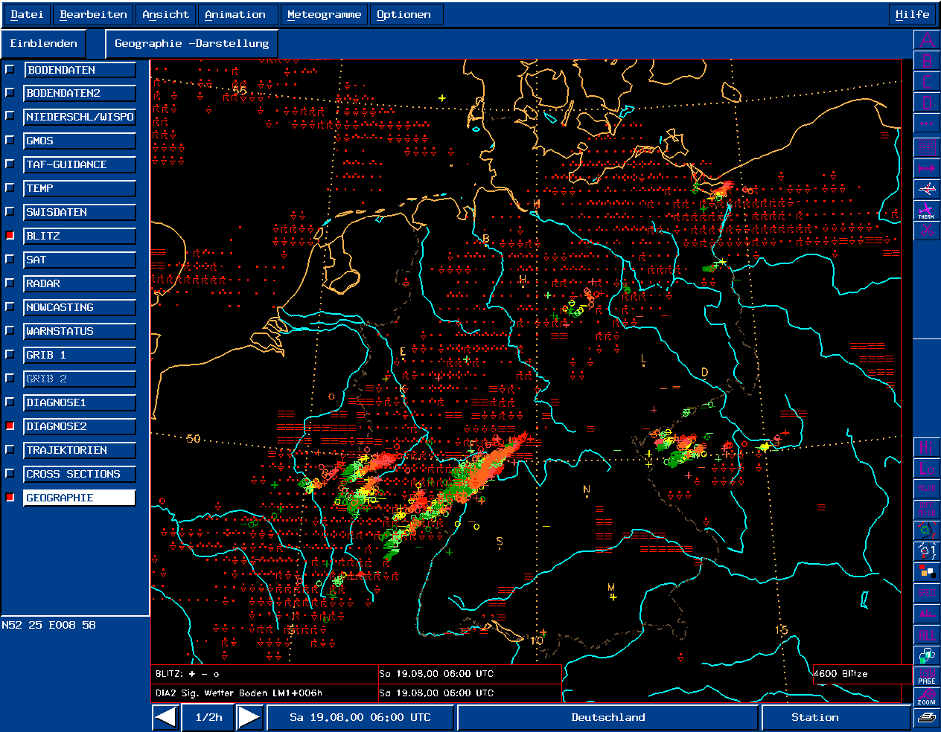
Fig.4 : Overlay of LM weather forecast and observed hourly lightnings at 19-08-00 06 UTC. B denotes Berlin

Summarizing the comparison of forecasted and observed thunderstorm development one gets the following results :

- LM on principle caught the existence of thunderstorm activity over Central Europe along the frontal zone and the movement of activity centers to the northeast.
- But there was a specific and typical overforecasting of the extension of thunderstorm regions and a shift of the temporal maximum of activity from abserved late afternoon and early evening towards early afternoon.
- Concerning the local Berlin storm event, thunderstorm activity was expected by LM from 13 to 17 UTC, the observed hailstorm was between 16.30 and 17.30 UTC.

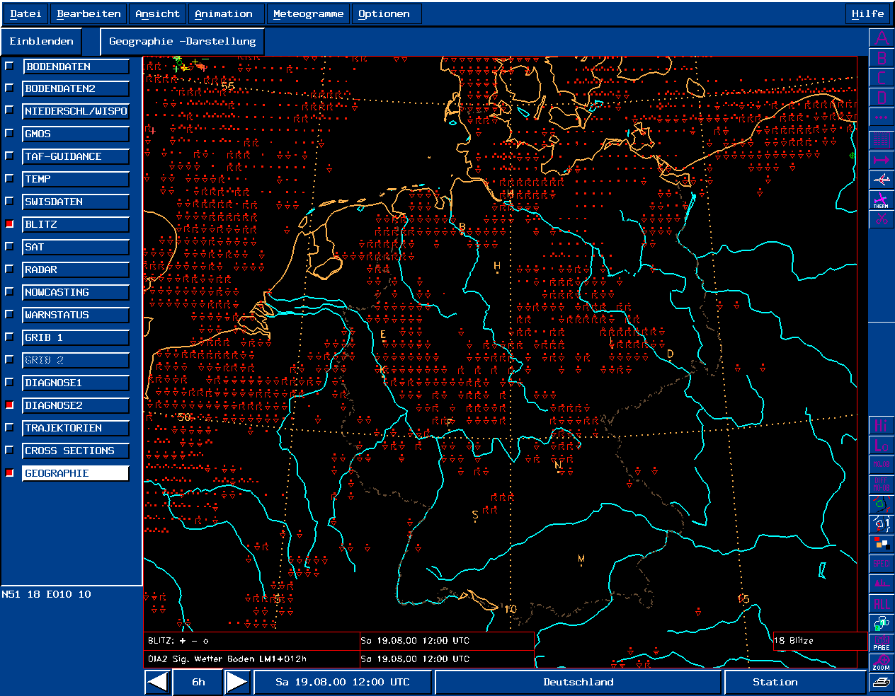
B
B
Fig.5 : Overlay of LM weather forecast and observed hourly lightnings at 19-08-00 12 UTC.
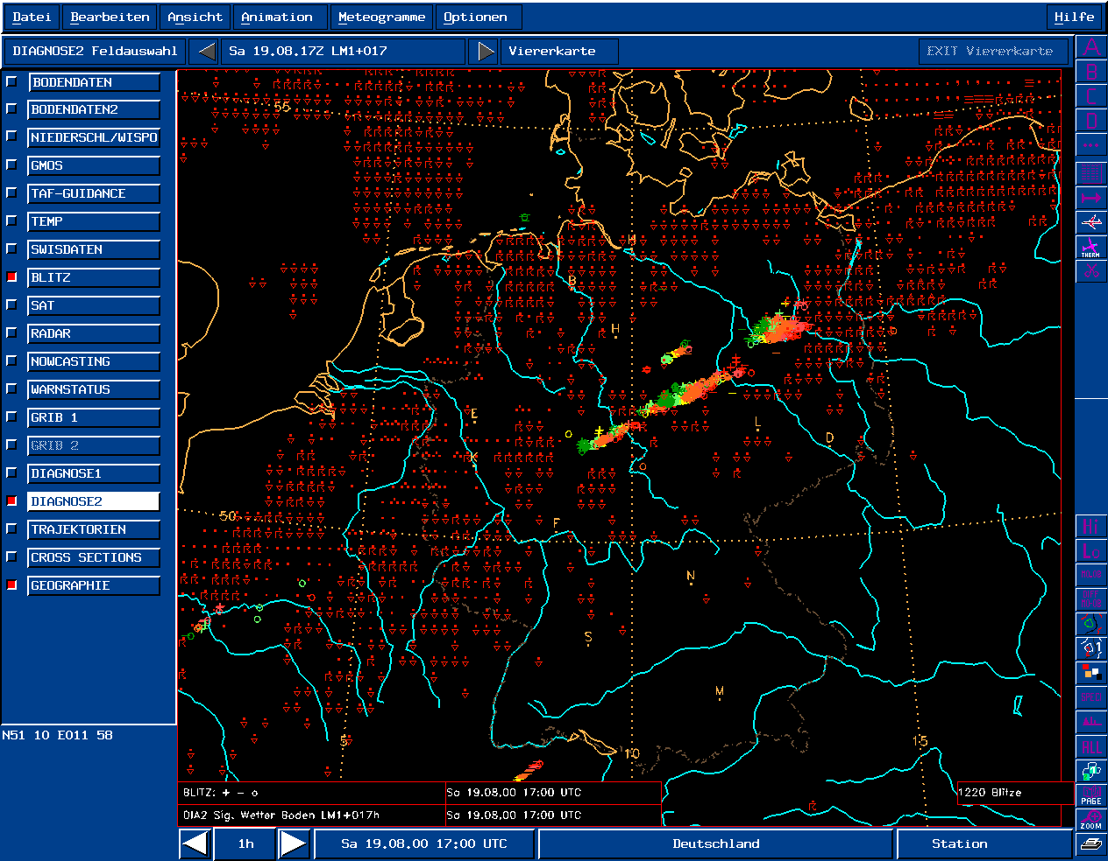
B denotes Berlin

Fig.6 : Overlay of LM weather forecast and observed hourly lightnings at 19-08-00 17 UTC
B denotes Berlin

The forecaster is interested not only in areal distribution and temporal development of thunderstorms but also in possible indications of the model that severe weather (hail) could happen. A close-up inspection of LM forecasts and observations concerning this aspect revealed the following finding :
- In the cluster of LM-thunderstorm activity forecasted to cross the Berlin area
between 13 and 17 UTC several incorporated LM pixels displayed icons of severe thunderstorm (hail).
- LM pixels with severe thunderstorm (hail) passed south and southeast of Berlin with a nearest distance of about 70 km (Fig.7).

Therefore it can be stated, that there was regionally, though not locally, a LM signal for a possible occurrence of thunderstorms with hail.

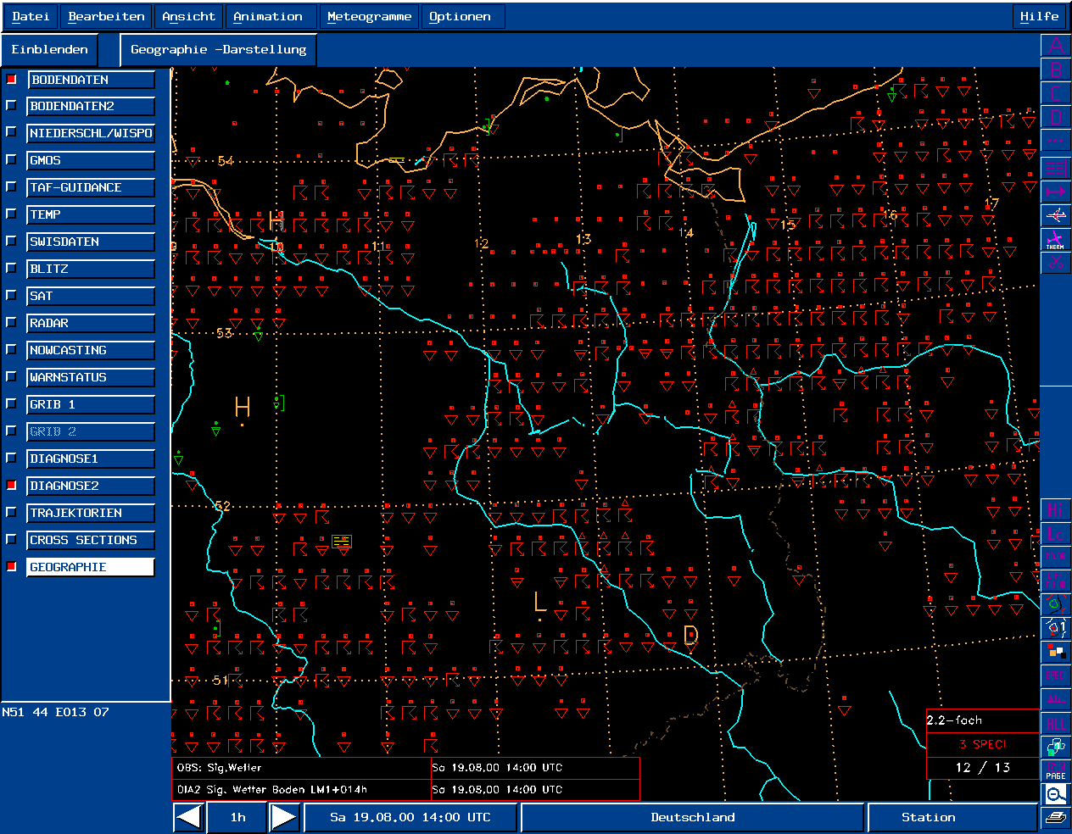
- The LM severe weather was relatively close to the real severe weather.
Fig. 7 : Overlay of LM weather forecast and observed weather at 19-08-00 14.00 UTC
B
B denotes Berlin

4. What does the Berlin Hailstorm Case Study teach us for the Verification
Procedure ?

Interpretation of verification and forecast value

Case studies like that for the Berlin hailstorm event directly show the degree of quality, value and implications of severe weather forecasts. The Berlin case demonstrates the scale-complexity of forecasts and that verification is also an interpretational task. Depending on the scale of space and time the quality of the LM forecasts had various implications :

- Considered locally for Berlin the deficits were : Errors in time and errors in intensity taking the LM forecast directly for the location of Berlin.
- Regionally considered, the LM tended to spread out weather structures like a "carpet" instead of describing weather objects, by that creating high rates of false alarms.

The experienced forecaster knows that with today's models one has to interpret pixel-based weather pattern not as forecast of real clusters but as a probability distribution of thunderstorms, that has to be interpreted. He/she also learns that there is a typical model shift of time of daily maximum thunderstorm activity.

- Inspite of some deficits of the NWP model forecast the forecaster could extract at that day a reasonable value from it.
- The most important question for him/she was : Could severe storms happen in the greater Berlin region at that day? This question got a fair regional answer.

Implications for the quantitative evaluation

The Berlin hailstorm is not only a good example for the demonstration of the value of qualitative case studies but also for possible restrictions when applying traditional quantitative verification. Two questions may be addressed :

- Are statistical verification scores always applicable ?
- How to handle verification cases with apparent "nearby" events ?

For yes/no forecasts of weather types (thunderstorm or severe thunderstorm) contingency table statistics may be the basis for evaluation. Three principle situations may occur for a region at a day with impending thunderstorms :

- Valid times with "yes" forecasts as well as "yes" observations
- Valid times with "yes" forecasts but no "yes" observations
- Valid times with "yes" observations but no "yes" forecasts

At valid times of the first case scores like POD, FAR, BIAS and CSI can be easily evaluated. For valid times of the second case the "yes" forecasts have no hits. POD and BIAS cannot be calculated. Nevertheless there is apparently a specific bias of the "yes" forecasts, an overforecasting. At 19 August 2000 both cases occurred, the second case occurred for 12 UTC.

For valid times of case three there are no "yes" hits and FAR cannot be not calculated.

- Sometimes one faces restrictions when assessing quantitatively weather forecasts.

From the viewpoint of traditional quantitative evaluation the Berlin-hailstorm case verification should have resulted in a total "miss" regarding the question of local severe thunderstorms : The LM did not forecast severe thunderstorm directly for gridpoints over Berlin. On the other side forecast hail-pixels existed in a distance of only 70 km. The forecaster could have interpreted this as advice for possible hail also over Berlin.

- As a consequence quantitative evaluation should be adapted to the given forecast situation and be performed with an adequate procedure.
- For the Berlin case the adequate procedure could have been the definition of a specific valid circle of evaluation.

